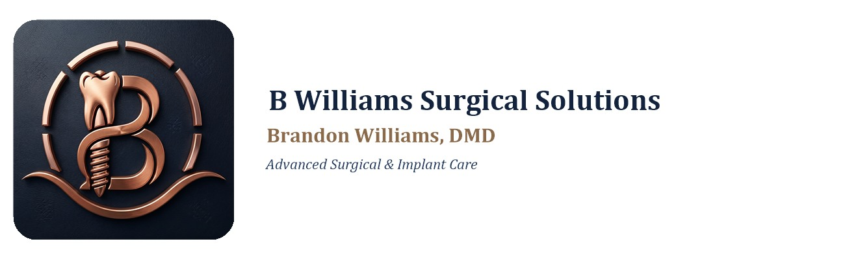

SURGICAL EXTRACTION / IMPACTED WISDOM TEETH
Procedure-Specific Informed Consent
Procedure Description
Removal of a tooth (or teeth) that is impacted, partially erupted, fractured below the gumline, or otherwise unable to be removed with a simple extraction technique. Surgical extraction may involve reflecting the gum tissue, removing a portion of bone, and/or sectioning the tooth into pieces to allow removal. This form applies to surgical removal of any tooth, including impacted or partially erupted third molars (wisdom teeth).
Benefits of Treatment
- Eliminates pain, infection, or disease associated with the tooth
- Prevents future crowding, cyst formation, or damage to adjacent teeth caused by impacted teeth
- Removes a tooth that cannot be restored or maintained in a healthy, functional state
- Reduces risk of future orthodontic relapse or root resorption of neighboring teeth (wisdom teeth)
Risks and Possible Complications
- Pain, swelling, bruising, and limited jaw opening (trismus) for several days to weeks
- Bleeding at the surgical site
- Infection requiring further treatment or antibiotics
- Dry socket (delayed healing with increased pain), particularly with lower teeth
- Damage to adjacent teeth, roots, or restorations
- Temporary or, in rare cases, permanent numbness or altered sensation of the lip, tongue, cheek, or chin (from proximity to the inferior alveolar or lingual nerve)
- Jaw soreness, stiffness, or joint (TMJ) discomfort
- Sinus exposure or communication with the sinus (upper teeth), which may require additional care or, rarely, surgical repair
- Jaw fracture (rare)
- Incomplete removal of a root tip, which may be left in place if removal would create greater risk, requiring monitoring
- Need for additional procedures or referral to an oral surgeon if complications arise
Alternatives to Treatment
- Monitoring/observation without immediate removal, where clinically appropriate
- Root canal treatment, if the tooth is restorable and not impacted
- Coronectomy (removal of the crown while leaving deep roots undisturbed to protect a nearby nerve), in select cases
- Referral to an oral and maxillofacial surgeon or ENT
- No treatment, with the understanding that risks of infection, cyst formation, crowding, or damage to adjacent teeth may increase over time
Patient Acknowledgement and Consent
I confirm that the treating dentist (or a member of the clinical team acting on the dentist's behalf) has explained the recommended treatment described above, including its expected benefits, the risks and possible complications, and the reasonable alternatives, including the alternative of no treatment. I have had the opportunity to ask questions about this treatment, and my questions have been answered to my satisfaction. I understand that dentistry is not an exact science and that no specific result or outcome has been guaranteed to me. I understand that unforeseen conditions may be discovered during treatment that require a change to the plan described here, and I authorize the treating dentist to make reasonable adjustments to the treatment plan as professional judgment requires. I understand I will receive care instructions related to this treatment and that it is my responsibility to follow them and to contact this office promptly with any questions or concerns. Having read and understood the above, I voluntarily consent to the treatment described in this form.
Patient Name (print): _______________________________________________________
Date of Birth: ____________________ Date: ____________________
Tooth #(s) / Treatment Area: _____________________________________________

Patient (or Parent/Guardian) Signature: _____________________________________________
Providing Dentist (print name): _____________________________________________
Brandon Williams, DMD • Advanced Surgical & Implant Care

